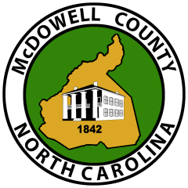
MCDOWELL COUNTY TAX OFFICE

TAX CERTIFICATION REQUEST

Date

Parcel ID

Physical Address

Grantor Name

NOTE: Tax Certification will be faxed or emailed to requestor and must be submitted to the Register of Deeds Office with the deed for recording.

Please allow 2 business days for our office to complete your request.

Requestor Name/Firm:

Contact Information:

Phone Number
Fax Number
Email Address

Please submit this request either by fax to 828-652-8401 or email to: taxcertifications@mcdowellgov.com
60 East Court St. Marion, NC ▪ Phone 828-652-0701 ▪ Fax 828-652-8401 ▪ mcdowellgov.com

